1st November 2017

**YOKOHAMA Establishes New Rubber Materials Development Technology Based on Materials Informatics**

YOKOHAMA has established a development technology for rubber materials based on materials informatics. The new technology combines the simulation technology that emerged from the Company’s research aimed at fostering innovative thinking about rubber material design with data generated by its research on the design, processing, analysis and measurement of existing rubber materials. It also incorporates information and knowledge exploration using AI (machine learning). YOKOHAMA expects this new development technology to dramatically raise the accuracy and speed of the development of rubber materials with unprecedented high-performance characteristics.   
  
Tyre performance is greatly affected by the complex morphology of the rubber material, i.e., the dispersion, size, and quantity of polymer (rubber) and filler (carbon black, silica, etc.). In 2015, YOKOHAMA developed a simulation technology for multi-objective design exploration of rubber materials that has enabled it to run predictive simulations of the mechanical properties (elasticity, energy loss, etc.) of models of virtual rubber materials across a vast design space including various morphologies as design factors.   
  
The new technology’s use of AI to search through the vast amount of data from numerous simulation results (design factors and characteristic value data) makes it possible to derive the morphological design factors critical to achieving the desired performance and the related thresholds (limitation values) in a short period of time with a high degree of objectivity and quantitative accuracy. In addition, by using the design and processing parameters of existing rubber materials and the results obtained from analysis and measurement of those materials, the new development technology greatly improves the precision of material searches and thus reduces prototyping man-hours required by material development. In addition, the use of a new simulation technique (coarse-grained molecular dynamics simulations) makes it possible to analyse the mechanism by which the various design factors impact mechanical properties, which could lead to new development approaches in the future.   
  
Using this new technology to simulate a rubber material that could overcome the contradiction of combining superior rolling performance with high wear resistance, YOKOHAMA found that a filler radius smaller than the certain threshold value combined with a thinner than certain bound rubber layer formed on the filler’s surface delivered the desired result. In addition, coarse-grained molecular dynamics simulations unveiled the mechanism by which a smaller filler radius increased rigidity while a thinner bound rubber layer reduced energy loss.   
  
Materials informatics’ use of information science, such as AI, makes it an effective means for searching for new materials and substitute materials and for estimating the performance of these new and unfamiliar materials. Material searches to date have relied on researchers’ experience and intuition, but this new materials development technology will facilitate speedier discovery of new materials with the desired characteristics. In Japan, research in materials informatics is being advanced at many levels, including the Ultra High-Throughput Design and Prototyping Technology for Ultra Advanced Materials Development Project being coordinated by a government organization. Similar projects are being promoted in many other countries, including the United States, China, and some European nations.

##### *Conceptual diagram of materials informatics*

Materials informatics combines data obtained through simulations with the results of research on design, processing, analysis and measurement of rubber materials, which have been traditionally conducted separately. Its use of AI (machine learning) enables the speedy and precise discovery of useful information and knowledge.

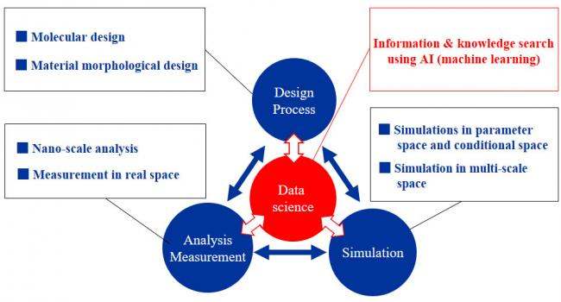

##### *Information and knowledge discovery process using materials informatics*

